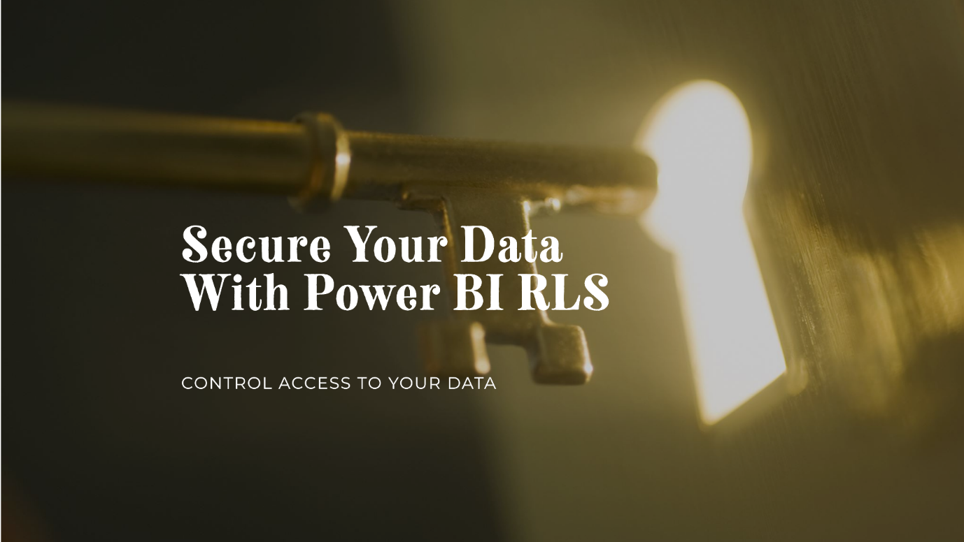

**Why Row Level Security**

In the realm of data analysis, safeguarding data integrity and confidentiality is paramount. Within Power BI, robust security measures such as Dynamic Row-Level Security (RLS), Static RLS, and Object-Level Security (OLS) are instrumental in fortifying data protection protocols. However, challenges may arise, particularly concerning the retrieval of location information through email in Dynamic RLS, where filtering out corresponding products may prove elusive. In response to this challenge, a meticulously documented approach has been developed to effectively address this issue. This document elucidates the comprehensive steps undertaken to mitigate this specific concern, ensuring a thorough understanding of the implemented solutions.

Dynamic and Static Row-Level Security (RLS): Dynamic RLS and Static RLS represent pivotal components of data security strategies in Power BI. Dynamic RLS enables real-time filtering of data based on user attributes or roles, dynamically adjusting data visibility to ensure compliance with security policies. Conversely, Static RLS establishes fixed filters on data, providing a more rigid approach to data access control. Object-Level Security (OLS): Object-Level Security (OLS) further bolsters data security by regulating access to specific data objects within the dataset. By delineating permissions at the object level, OLS facilitates granular control over data access, enhancing both security and manageability. Challenges with Dynamic RLS: Despite its efficacy in most scenarios,

Dynamic RLS may encounter challenges, particularly in retrieving location information via email. This challenge is compounded by the difficulty in filtering out corresponding products, thereby compromising data accuracy and accessibility.

***Addressing the Challenge***: To effectively resolve the issue at hand, a systematic approach has been meticulously crafted. Each step is meticulously documented to ensure clarity and comprehensiveness in implementing the solution.

* Identifying the Scope: The first step entails a thorough analysis of the challenge, pinpointing the specific scenarios where Dynamic RLS fails to retrieve location information accurately via email.
* Analyzing Data Structure: Comprehensive examination of the data structure is conducted to discern the underlying factors contributing to the challenge. This involves scrutinizing email-based data and its correlation with location information and product attributes.
* Developing Custom Filters: Leveraging the flexibility of Power BI, custom filters are devised to intricately address the nuances of the challenge. These filters are tailored to refine data retrieval processes, ensuring precise alignment with location-specific email inquiries.
* Testing and Validation: Rigorous testing procedures are employed to validate the efficacy of the implemented solution. This involves simulated scenarios and real-world data samples to ascertain the accuracy and reliability of the refined data retrieval mechanism.
* Documentation and Training: Thorough documentation of the entire process is meticulously compiled, elucidating each step taken and rationale behind the decisions made. Additionally, training sessions are conducted to familiarize stakeholders with the refined data retrieval protocols, ensuring seamless adoption and adherence to best practices.

**To recapiculate**: By meticulously documenting each step taken to address the challenges encountered in Dynamic RLS, this document provides invaluable insights into enhancing data security measures within Power BI. Through a systematic approach encompassing custom filters, rigorous testing, and comprehensive documentation, the efficacy of data retrieval processes is significantly bolstered, ensuring optimal data integrity, confidentiality, and accessibility.

**Simple and Complex RLS Setup**

**Simple RLS Steup**

First, you need to upload the data attached to the file. Then, create the charts as instructed below.

1. To create a Matrix chart, you will need the entire Sales Data. Once you have it, upload it onto the matrix chart.

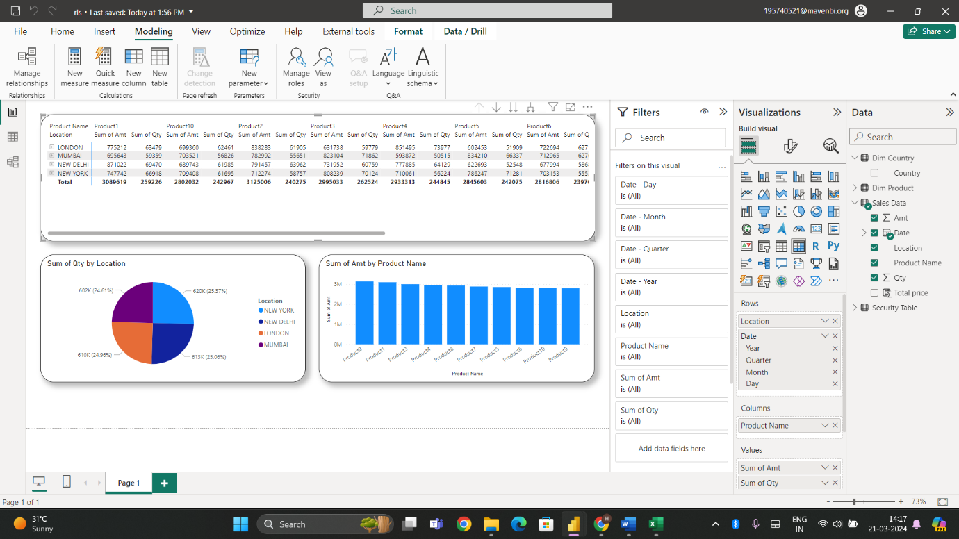

2. To create a Pie chart, you need to extract data from the Location and Qty columns in Sales Data.

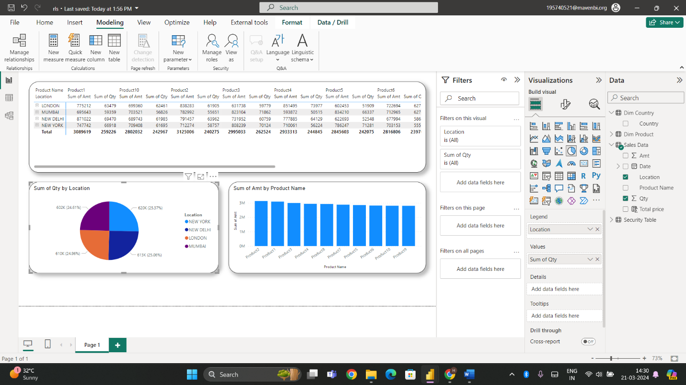

3. To create a bar chart, you need to extract data from the Amount and Product Name columns in Sales Data.

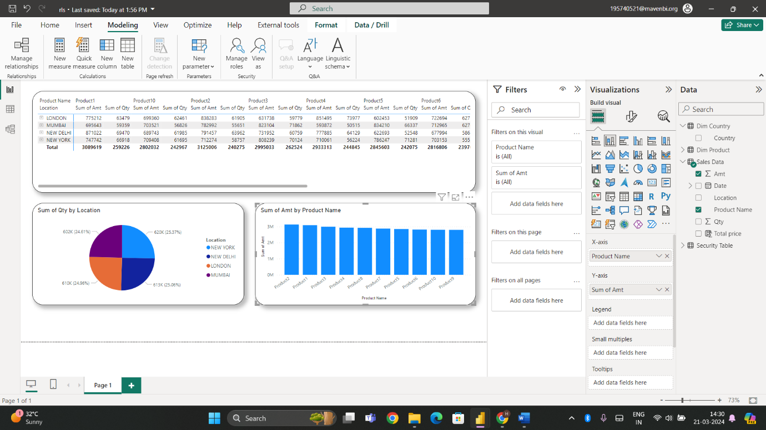

4. Please follow these steps:

1. Navigate to the Model View.

2. Establish a relationship between the "Country" column in the "Security" table and the "Location" column in the "Sales Data" table.

3. Select the option "Apply security filter in both directions".

4. Click "OK" to save the changes.

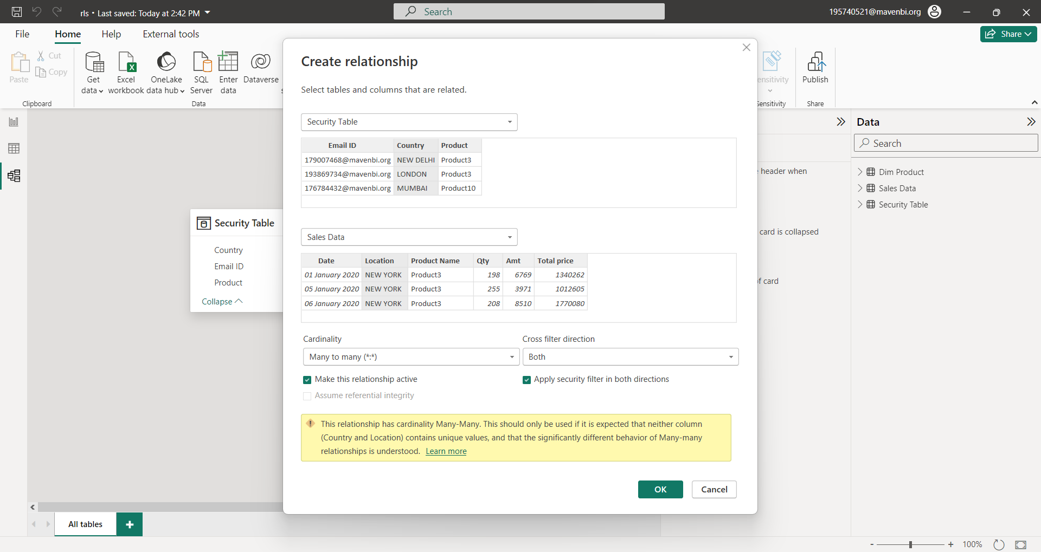

4 .After returning to Report View, click on the Modeling option in the main menu tab and then select Manage Views..

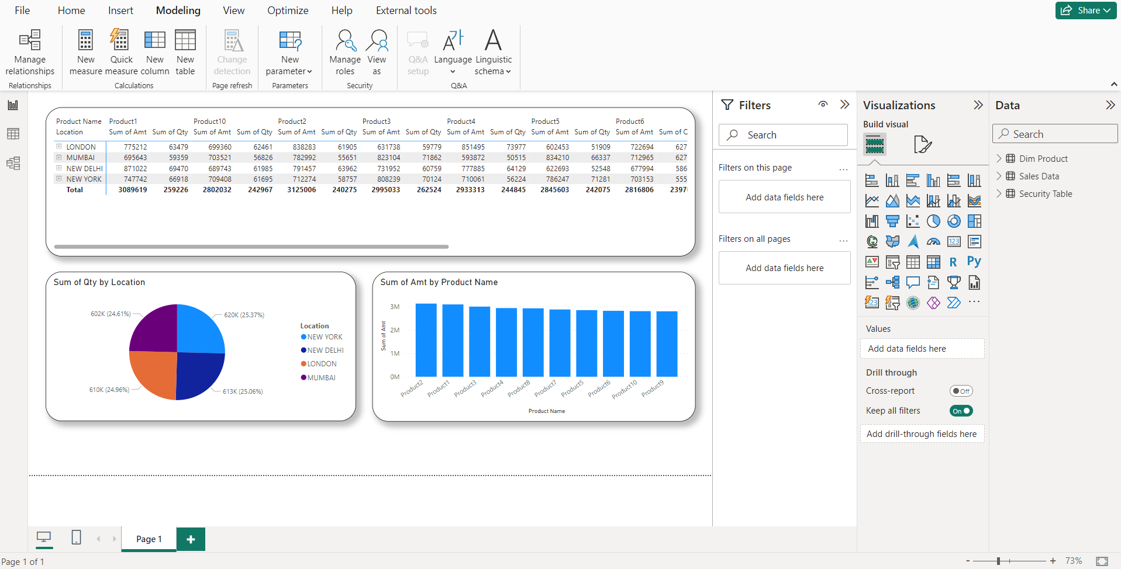

5. After clicking on "Manage Roles", a new window will appear. In the "Roles" section, you can create a role by giving it any name you prefer. For example, you can name it "Simple RLS". Once created, you can find it in the "Tables" pane. Click on the ellipses next to the "Security" table and then click on "Email ID". Add the expression as [Email ID] = USERPRINCIPALNAME() and save the changes.

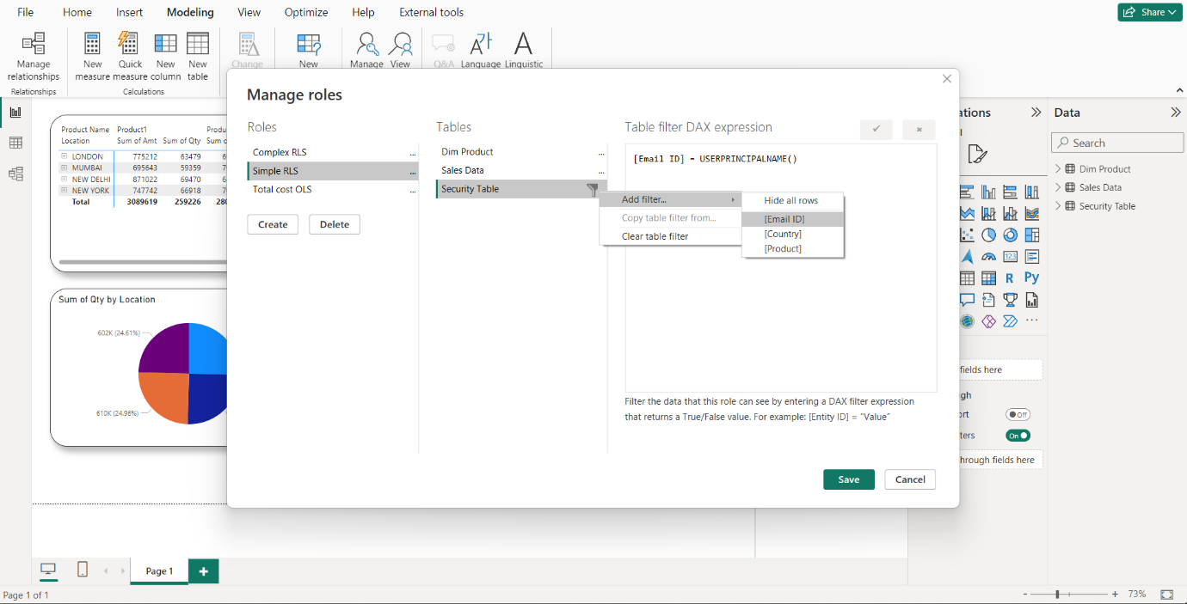

6 Additionally, once you have saved the file, it may take some time to load. Then, select the "View" option and apply the filters as shown below. Finally, click on "Save". Please note that the user email dataset needs to be updated according to the email addresses in your organization. Therefore, kindly update the email addresses in the Excel sheet before proceeding.

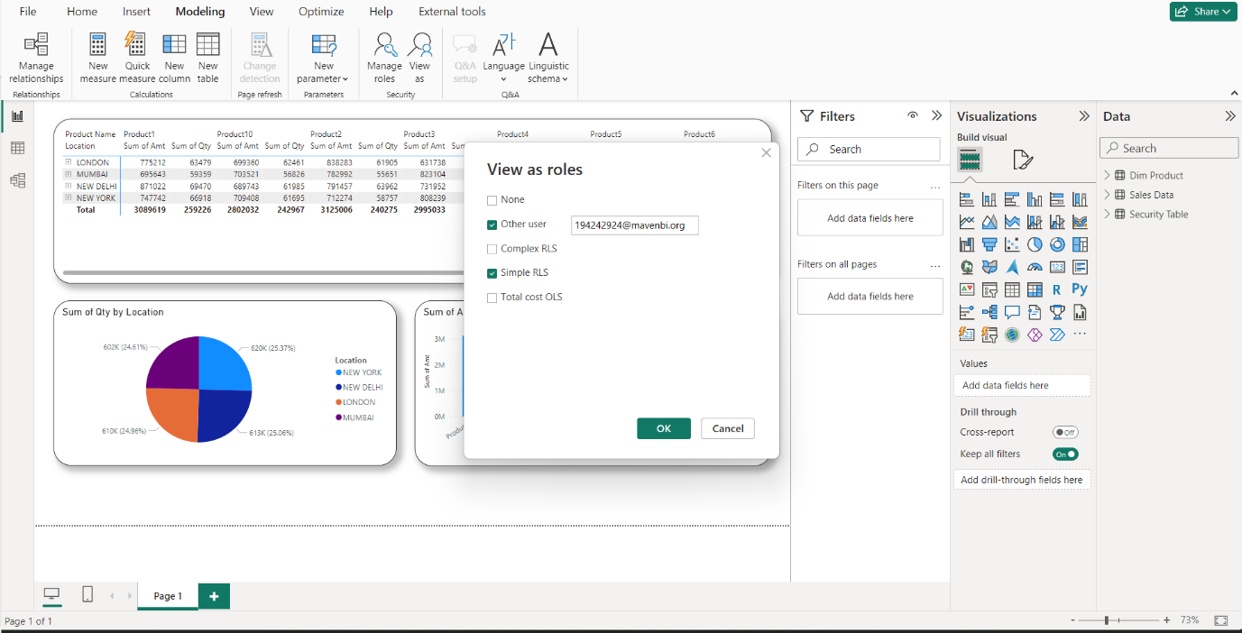

7. Finally, this is how you will see the result as on Desktop.

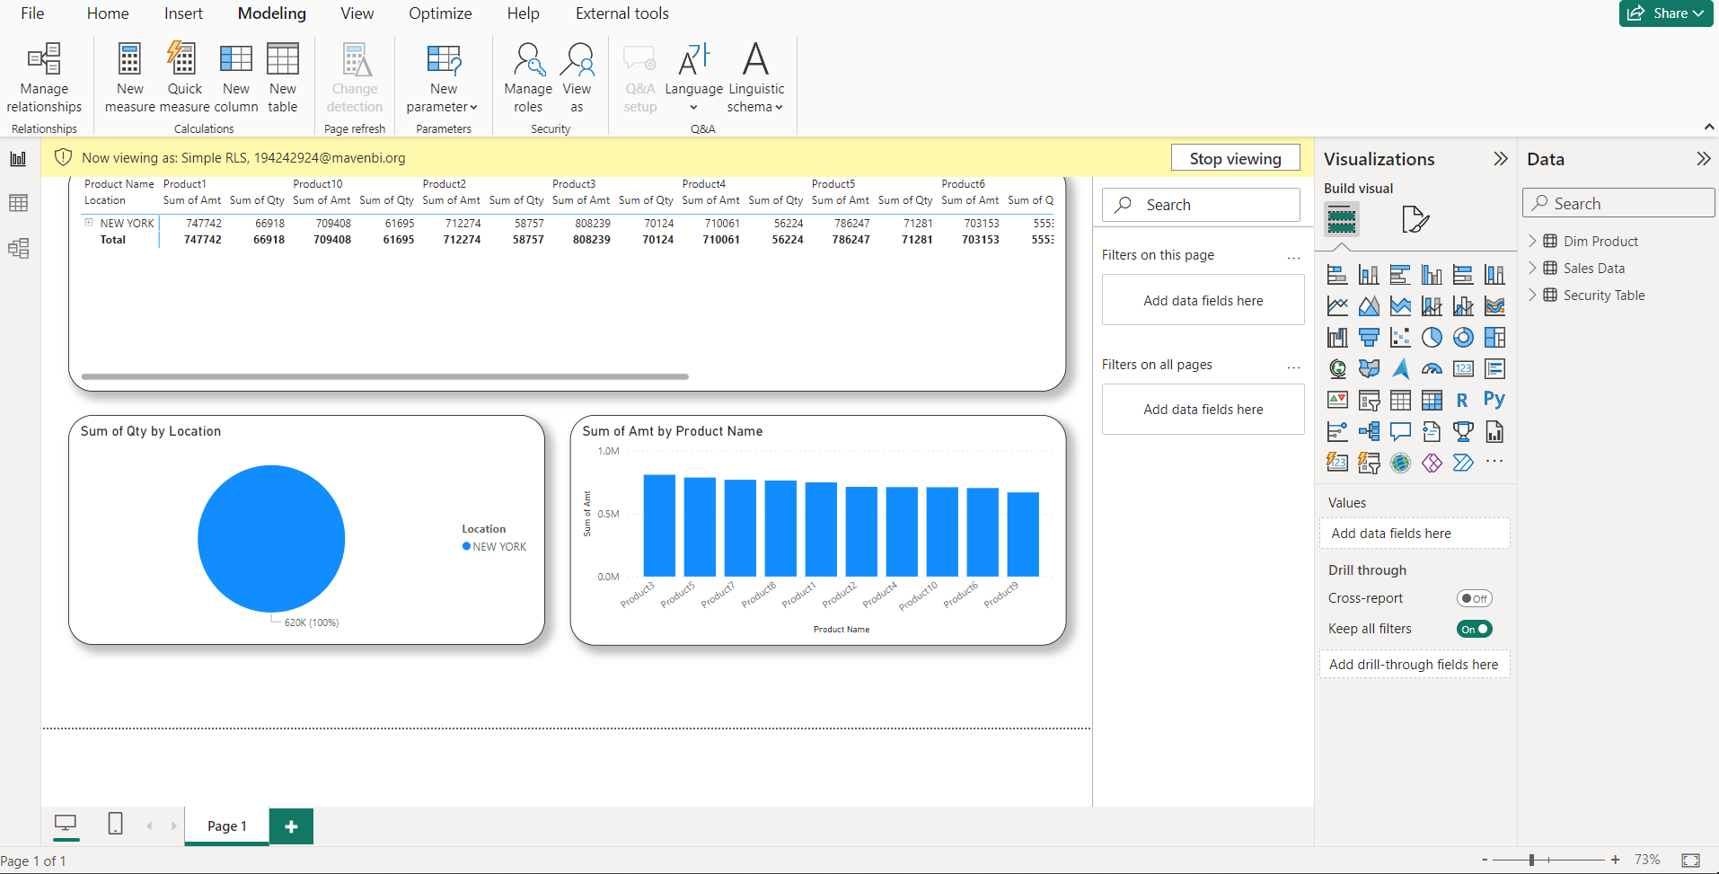

8 To publish a report on the Power BI service, go to the Home tab, click the Publish button, and follow the steps provided.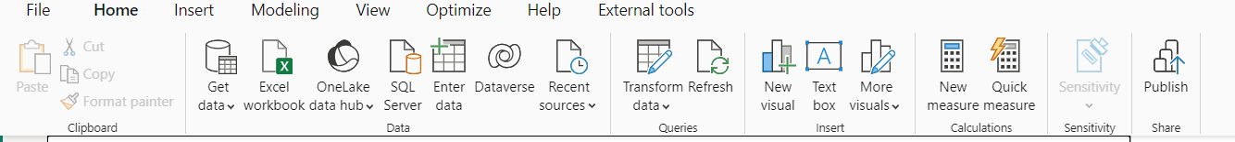

9. If you have an email organization or student email then only you will be able to log in or else if you want a free trial, you can visit this site [Free Service account](https://app.mavenanalytics.io/login)

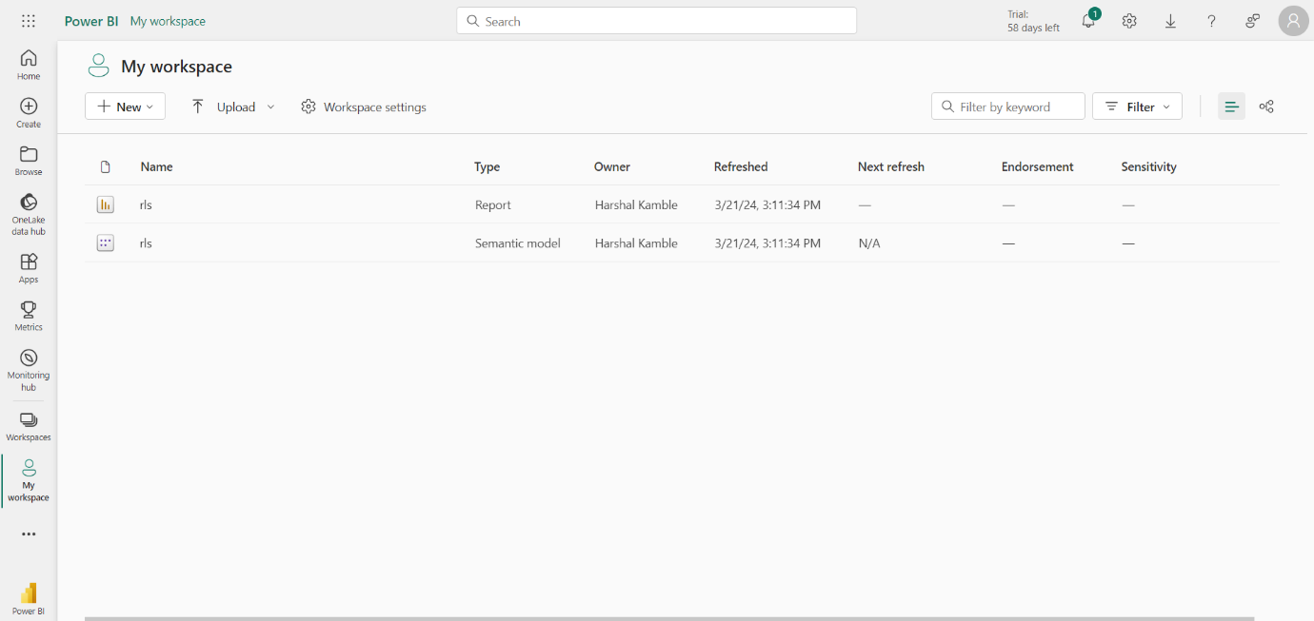

This is how an interface will look like when you click on my workspace.

10. Click on "rls Semantic Model" and click on "security" from the ellipsis.

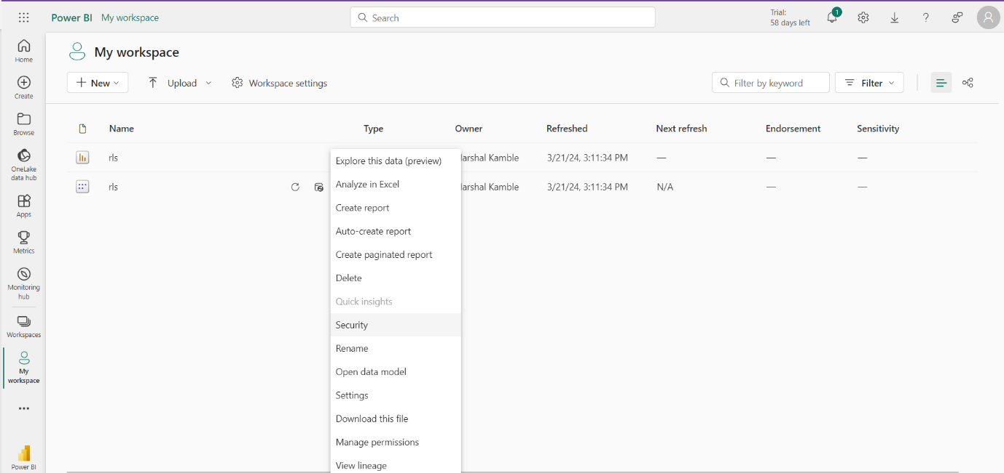

11. Visit Simple RLS or the designated role, add emails from your organization, and click "Test as a role".

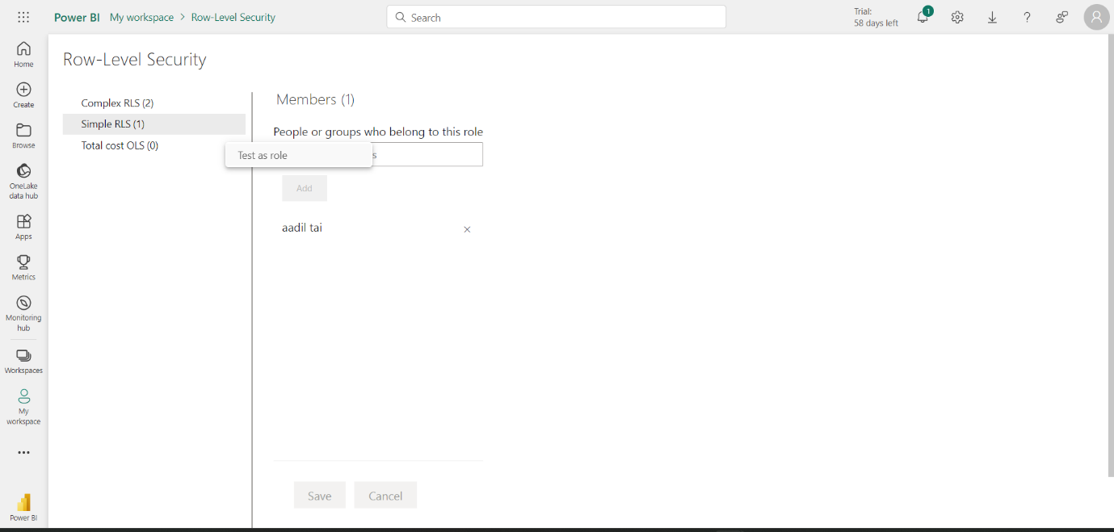

11. Please navigate to the "Now Viewing" section, make the necessary changes, and click on the "Apply" button to save the changes.

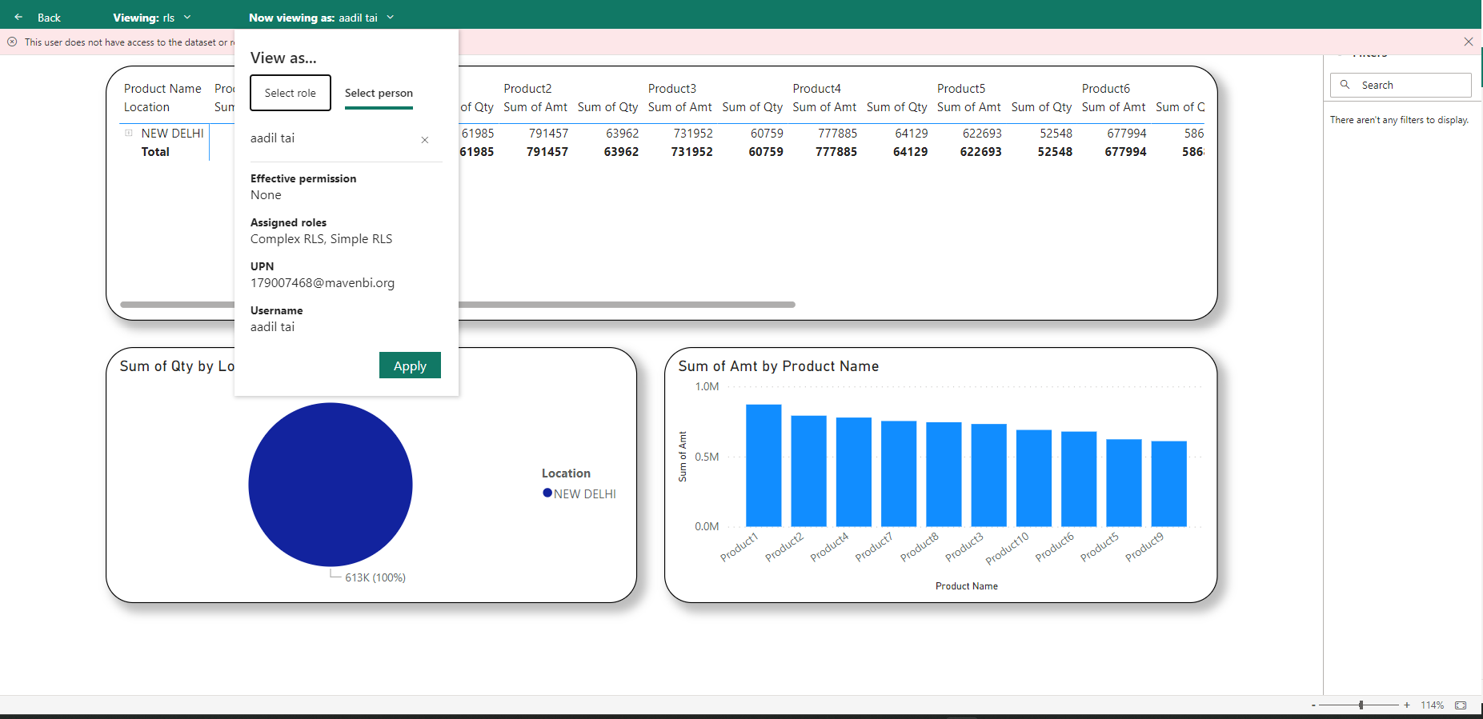

**Complex RLS Steup Includes Country along with Product**

Explore the Simple RLS setup in detail and pave the way to a better understanding of complex information in the Complex RLS setup. Let your journey of learning begin!

1. To create the same relationship as seen in the image below, you can repeat the steps from 1 to 3 stated above

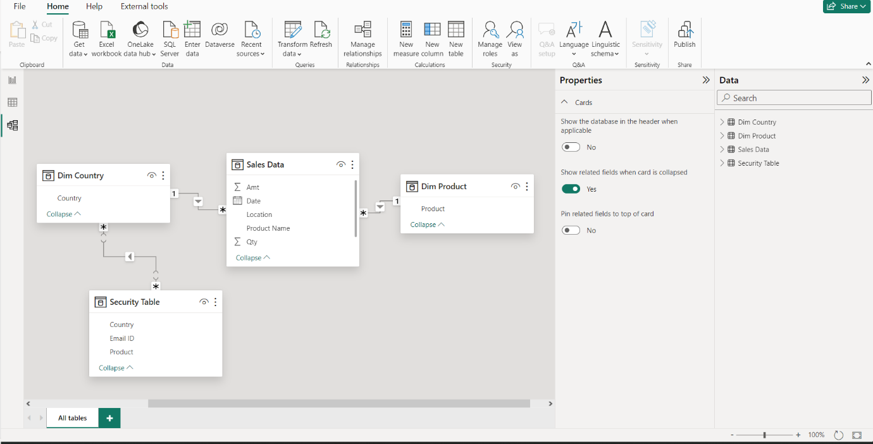

2. To complete a task, follow these steps:

* Switch to Model View and establish the required connections.
* Return to Report View and navigate to the Manage View option under the Modeling Tab in the Main Menu tab.
* In the Tables pane, select Dim Country and upload the DAX expression as shown.

Dax Expression (

VAR User = LOWER(USERPRINCIPALNAME ())

VAR RLSValues = SELECTCOLUMNS(FILTER('Security Table', 'Security Table'[Email ID] = User),"AllowedValues",'Security Table'[Country])

RETURN

'Dim Country'[Country] IN RLSValues)

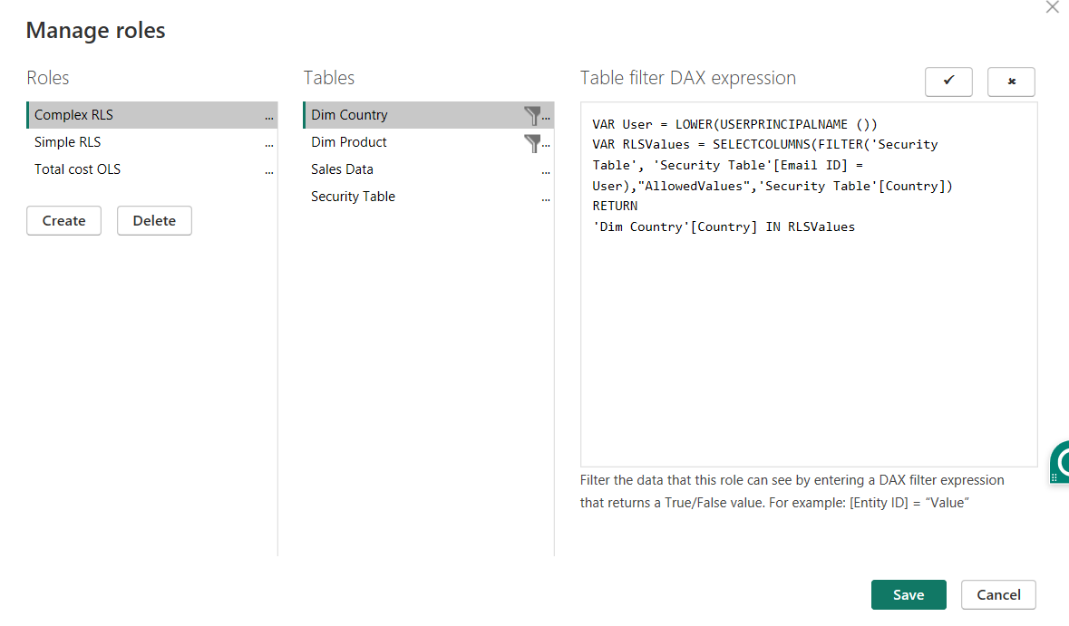

3 .Follow the same steps for Dim Product. Remember not to add it to the column filter. Just select Dim Country or Dim product. Don't click on ellipsis and click on save.

Dax Expression (

VAR User = LOWER(USERPRINCIPALNAME ())

VAR RLSValues = SELECTCOLUMNS(FILTER('Security Table', 'Security Table'[Email ID] = User),"AllowedValues",'Security Table'[Country])

RETURN

'Dim Country'[Country] IN RLSValues

)

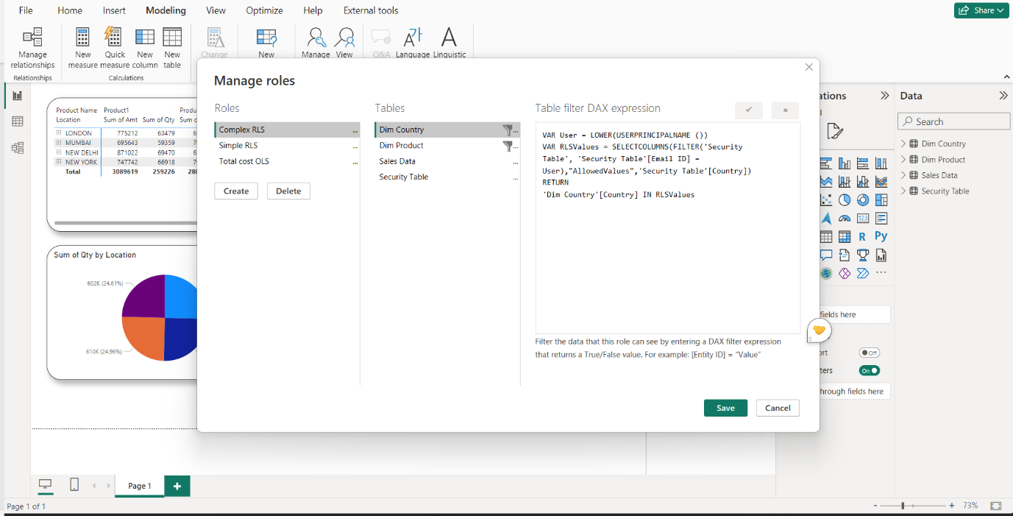

4. After completing the Manage Roles, navigate to View As, upload the employee's email address, and click OK.

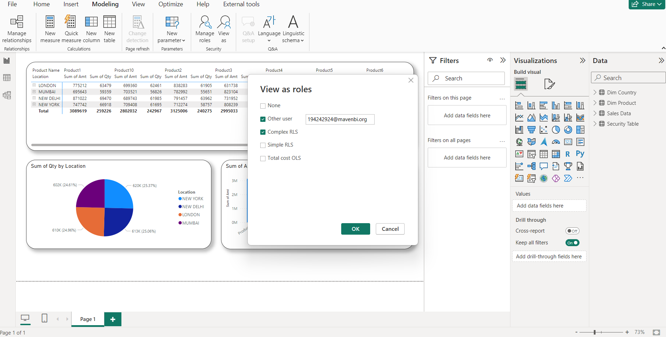

5. These is how it will look lilke

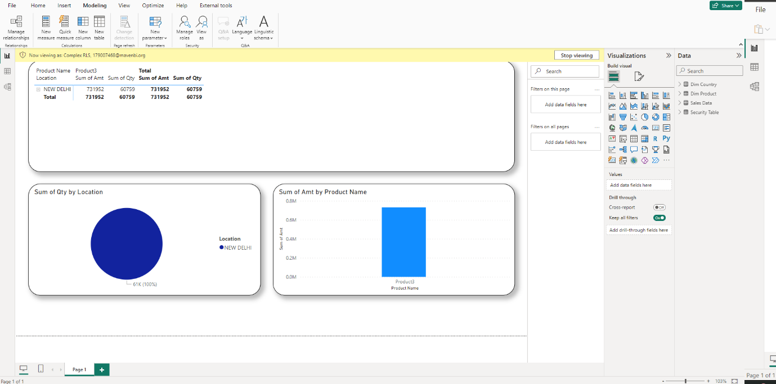

6. Now, to add members from your organization to complex RLS, you need to follow almost the same steps as for service.

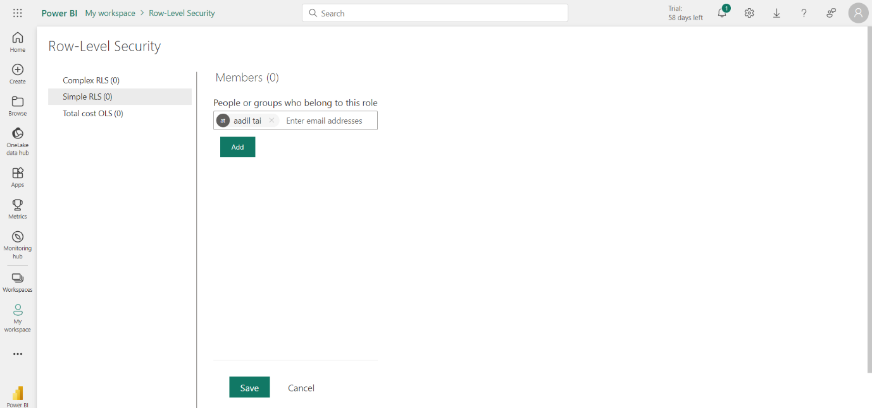

7. After clicking on the test role you get the result

